

Project Report
Software Engineering
For Implementing SDLC while developing
Inventory Management System

Student Name : Muzamil Khan
Student ID: 11508
May, 2022
Submitted to: Sir Sohail Imran

CoCIS, PAF Kiet University, Karachi, Pakistan.
Executive Summary

This report covers major "Software Development" activities on our selected Software. This project activity lasts for duration of 3.5 month time period.

Index

Executive Summary ___________________________________________ II
Index __________________________________________________________ III

- Project Initiation: Proposal Form ___________________________ IV
- Requirement Engineering and Configuration Management ______ V
- Project Management and Risk Management _________________ VI
- Monitoring (Analysis and Design) already covered in SRS 2. _______VII
- Testing Plan and Report ________________________________VIII

Conclusion of whole Project ____________________________________ IX
- PROJECT INITIATION: PROPOSAL FORM
Page IV
1. Motivation: The motivation should clearly specify why this project is being made. The project “Inventory Management System”is made to add users roles, categories, inventory items list etc. The C# ASP.NET MVC Web application technology is used. ----------------------------------------------------------------------------------------------------------------

2. Functional Features Specify the features of your project which would make it significant for the evaluators. 1. If you are designing a project, which is in common use then you should specify those features which are making your project distinctive/unique in comparison with the existing ones “Totally a professional concept of implementing a CRUD based Product”.
2. Indicate the utilization/benefits of your project “Will demonstrate implemention of all engineering activities expected under different pahses of SDLC on Product Development”.

3. List down 5 unique but relevant Modules/Features for 5 members a. Module 1: Login Authentication (Common for all members)

b. Module 2: Users c. Module 3: Suppliers d. Module 4: Roles e. Module 5: Purchase Invoice

4. Expected Detail of all Modules to be covered by each Member Member 1: Login + Module 2
1. Demonstration of Create actitivty on Module
2 2. Demonstration of Review actitivty on Module 2
- Demonstration of Update actitivty on Module 2 4.
- Demonstration of Delete actitivty on Module 2 5. Demonstration of Search actitivty on
- Module 2

Users New User can be created, edited, deleted in this module.
Member 2: Login + Module 3 1. Demonstration of Create actitivty on Module 3 2. Demonstration of Review actitivty on Module 3 3. Demonstration of Update actitivty on Module 3 4. Demonstration of Delete actitivty on Module 3 5. Demonstration of Search actitivty on Module 3

Suppliers: Suppliers information is handled in this module

Member 3: Login + Module 4 1. Demonstration of Create actitivty on Module 4 2. Demonstration of Review actitivty on Module 4 3. Demonstration of Update actitivty on Module 4 4. Demonstration of Delete actitivty on Module 4

Roles : Roles of person are created in this module of Inventory management system like General Manager, security manager, salesperson etc.

Member 4: Login + Module 5 1. Demonstration of Create actitivty on Module 5 2. Demonstration of Review actitivty on Module 5
3. Demonstration of Update actitivty on Module 5
4. Demonstration of Delete actitivty on Module 5 5. Demonstration of Search actitivty on Module 5 Purchase Invoice: Purchase invoice is made in this module which consists of product name, expiry date, price and other features.
- REQUIREMENT ENGINEERING AND CONFIGURATION MANAGEMENT
Page V

Functions of System Components:

Database:
• Stores data
• Creates reports
• Provides access to data
• Updates information

• Provides access to the database
• Authenticates users

2.2 Product Functions
This section provides a summary of the functions that the software will perform.
2.2.1 Function Relationships
Figure 2.2 to 2.6 depict the relationships among the functions to be implemented by the system.
Figure 2.2 Inventory Management System General Function Relationship/Higher Level Usecase Diagram

2.2.2 Function Descriptions (Functional Requirement Listings)

2.2.2.1 Log In Function

Description: This function ensures that only authorized users gain access to the Inventory Management databases. An authorized user is a user who has an account on the system. The user must type a valid username and password to gain access.

2.2.2 Module 1: Users

Description: This function allows the system to give access to users who can work with the database, they can login to the inventory management system and check for the stock, update the record, delete and perform search for any specific product.

2.2.3 Module 2: Suppliers/Stock

Description: This function has the ability to maintain the record of already entered stock information, this function has all the information regarding stock of the inventory, update new stock prices, delete the unnecessary item.s

2.2.4 Module 3:

Description: This function take cares of the purchase invoice, this function can show the purchase invoices of items sold in the inventory management system.
We are 3 members in group for Software Engineering project and we have minimum 4 modules in our system. Group leader is working on 2 modules(Suppliers/stock)

2.3 User Characteristics

The main users of the system ensures that only authorized users gain access to the Inventory Management databases. An authorized user is a user who has an account on the system. The user must type a valid username and password to gain access.The graphical interface provides an easy way of using the Inventory Management system with minimum of training.

Assumptions and Dependencies or Business Logic
The assumptions for the project are:
- We can check the record, update, insert, create, edit, delete and also search for the relevant items in our Inventory Management System.
- Main the record of our products.
- Create invoice of sold items.
- Update price of any item, check for availability of any item in inventory.
- Add new entry of product in the system.
- Remove items which are not available in the stock anymore.

3. Specific Requirements

This section of the SRS contains design requirements for the Inventory Management System.

3.1 Functional Requirements

3.1.1 Log In Function

Description: This function ensures that only authorized users gain access to the Inventory Management databases. An authorized user is a user who has an account on the system. The user must type a valid username and password to gain access.

- Usage Scenario/ Use case Description/ Specification:

Description | Allows access to Inventory Management System
Inputs | Username, password
Source | - User inputs username and password  - Press Login Button

Alternate case
Outputs | Successful login; unsuccessful login
Destination | None
Precondition | Authorized User
Post Condition | No change to Inventory Database
Side Effects | Failures and successful logins are sent to Database

- Detailed Use case Diagram for Login: optional

- Use case Realization for Login: optional

- Flow of Event or Data Flow Diagram for Login: optional

- Sequence Diagram for Login: optional

- Collaboration Diagram for Login: optional

- Activity Diagram for Login: optional

- Class Diagram for Login: optional

- State Chart Diagram for Login: optional

    - Module 1 Creating Users: complete CRUD Make the Users in the

Name :Hassam Saqib

ID: 9744

- Description: This function allows the user to [make | drop | view | update] the Users, allow the users who have provided their information like, name, username, password, email and phone, they need to register their selves first before logging into the sysem.

- Usage Scenario/ Use case Description/ Specification:

Description | [ make | drop | view | update] Add the user’s account in DB
Inputs | Name, Username, password, email, phone
Source | - User input name, username, password, email, phone
Alternate Case | If the inputs are invalid or incomplete show error message “please provide complete info”
Outputs | Added | Deleted | Viewed | Modified Users
Destination | After the information is provided for the user those info will be saved in Database, then user can log into system to use the system.
Precondition | Valid information; complete info provided, all input fields are filled.
Post Condition | Access to the login screen after providing the asked information,
Side Effects | If wrong or incomplete info is provided then error message will be shown

- Use case Diagram:

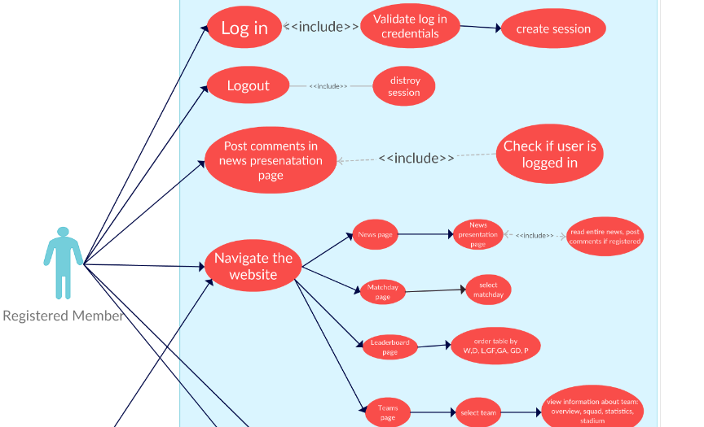

- Use case Realization:

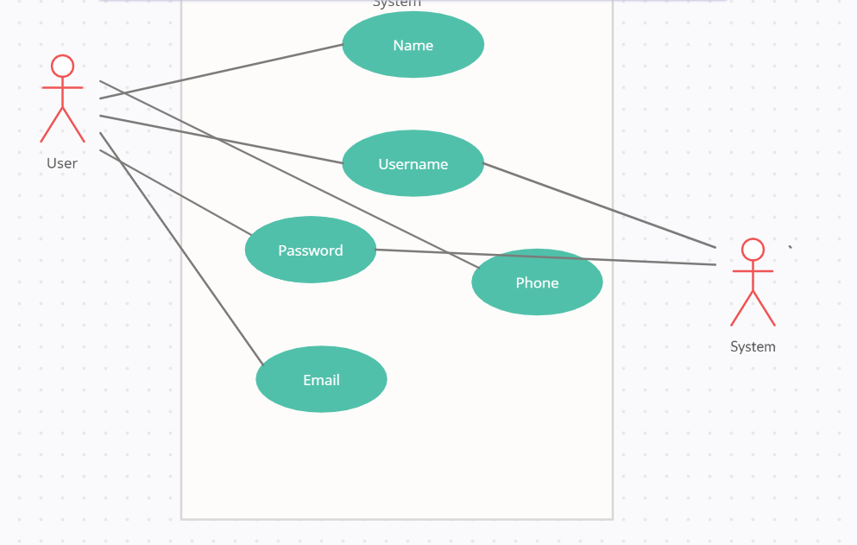

- Flow of Event or Data Flow Diagram:

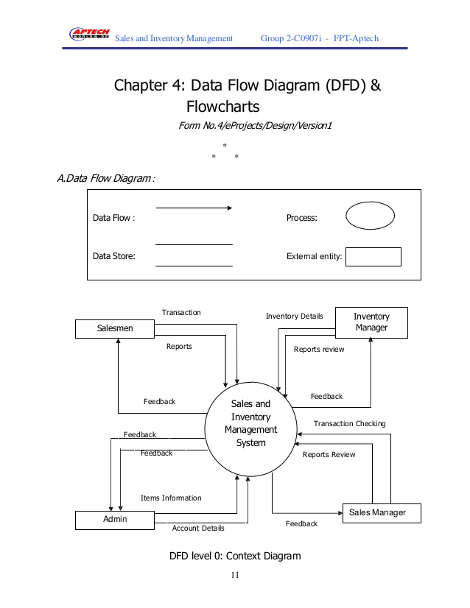

- Sequence Diagram:

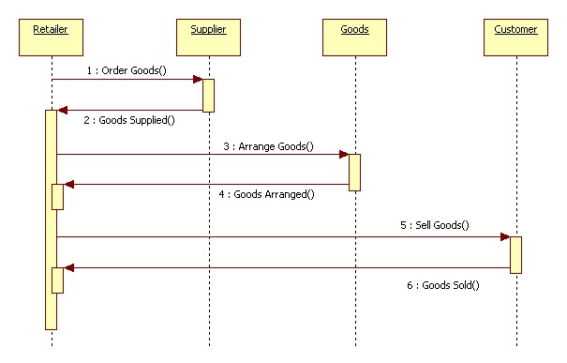

- Collaboration Diagram:

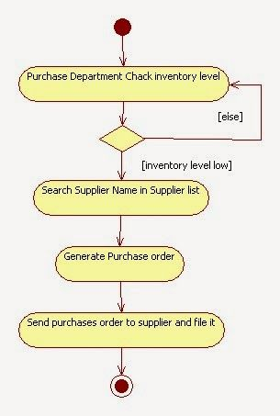

- Activity Diagram:

- Class Diagram:

- 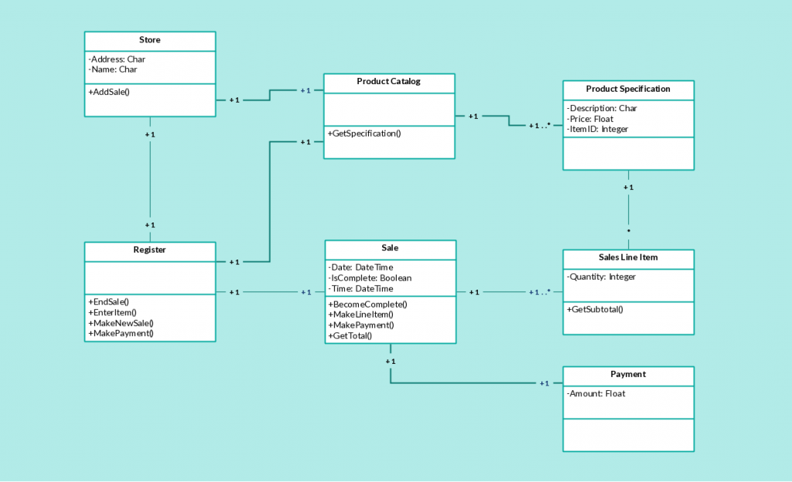

- State Chart Diagram:

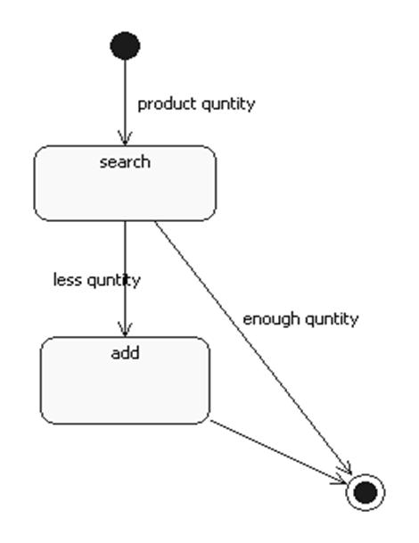

    - Module 3 Stocks/Suppliers complete CRUD Make Suppliers / Stock Function

Name : Muhammad Muzammil
ID : 9454

a) Description: This function to handle the suppliers and main record of products in the Inventory Management databases. Stocks items are updated, inserted, deleted in this function. New product can also be in added in stock, prices can be adjusted.

- Usage Scenario/ Use case Description/ Specification:

Description | [ make | drop | view | update] Add new items in stock, CRUD operation in DB
Inputs | Product name, date, expiry, price etc
Source | Name of the item, date, quantity, expiry date
Alternate Case | If the inputs are invalid or incomplete show error message “please provide complete info”
Outputs | Added | Deleted | Viewed | Modified Users
Destination | After the information is provided for the user those info will be saved in Database, then user can log into system to use the system.
Precondition | Valid information; complete info provided, all input fields are filled.
Post Condition | Access to the login screen after providing the asked information,
Side Effects | If wrong or incomplete info is provided then error message will be shown

- Use case Diagram:

- 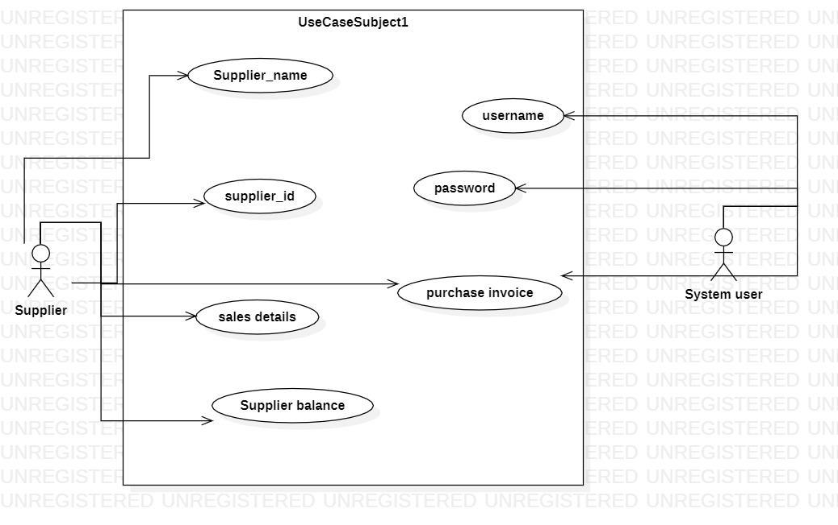

- Use case Realization:

- Flow of Event or Data Flow Diagram:

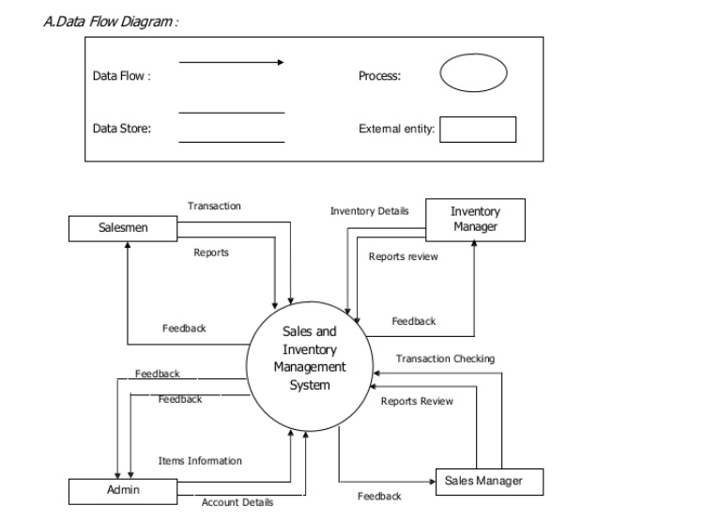

F) Sequence Diagram:

- 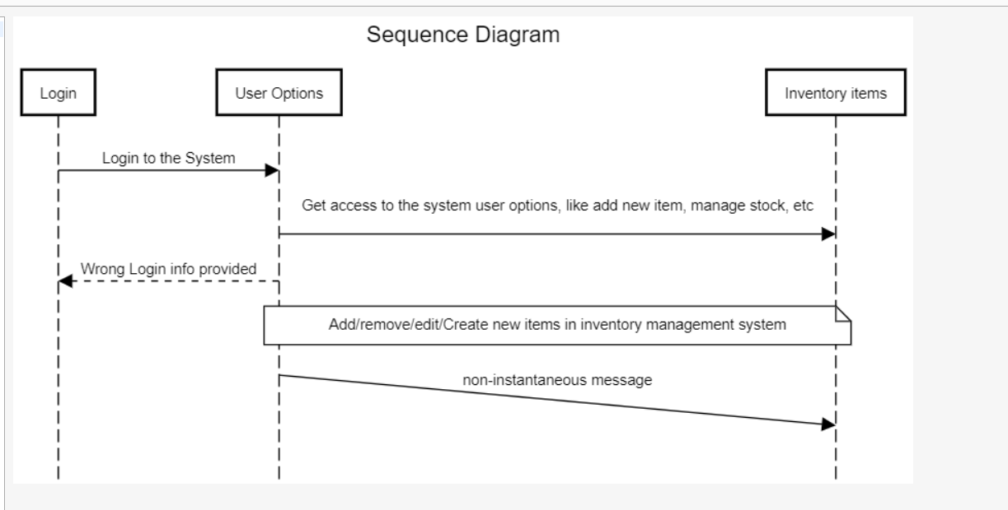

G) Collaboration Diagram:

H) Activity Diagram:

- 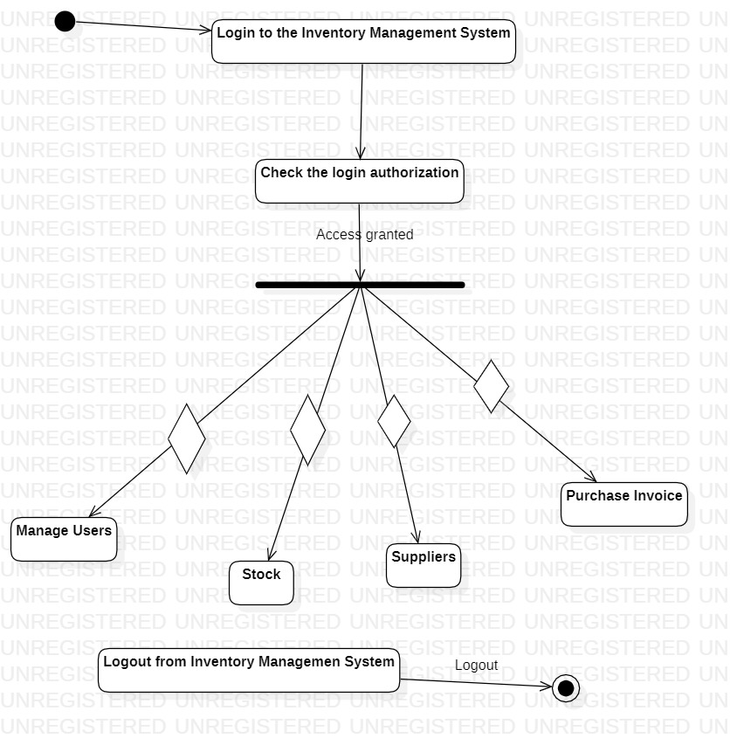

- Class Diagram:

- 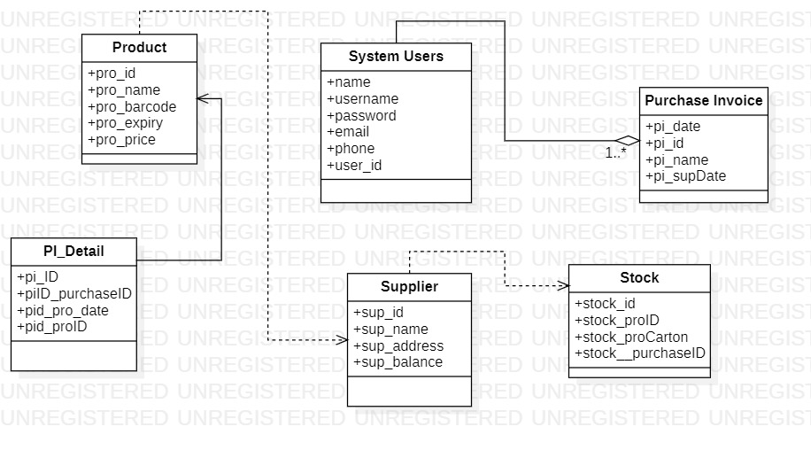

J) State Chart Diagram:

- 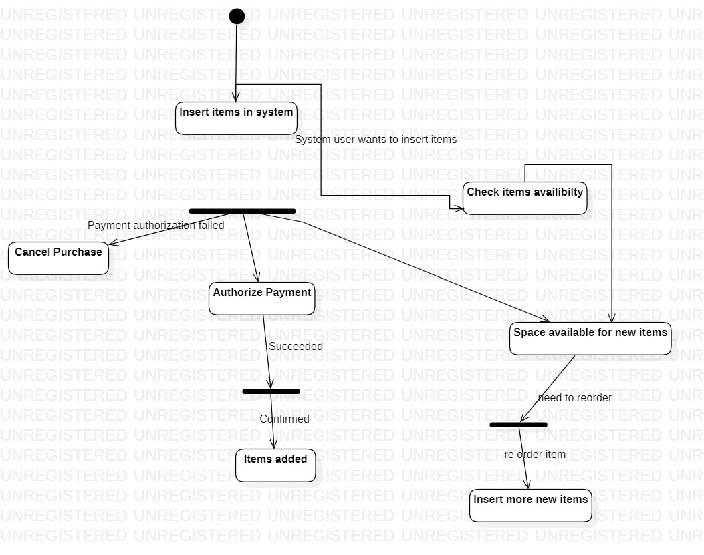

    - Module 4 complete CRUD Make the Purchase invoice/Payment options

Name : Taqi Ahmed
ID : 9762

a) Description: This function in our Inventory Management handles the Purchase invoice/Payment issues. Creates and maintain records for the sold items. Manipulate prices. All the information regarding suppliers and stock are shown here also.

- Usage Scenario/ Use case Description/ Specification:

Description | [ make | drop | view | update] Purhcase Invoice : maintain records for the sold items. Manipulate prices. All the information regarding suppliers and stock are shown here also
Inputs | Supplier balance, supplier phone, supplier address, pricing
Source | Name of the item, date, quantity, expiry date
Alternate Case | If the inputs are invalid or incomplete show error message “please provide complete info”
Outputs | Added | Deleted | Viewed | Modified purchase invoice
Destination | After the information is provided for the user those info will be saved in Database, then user can log into system to use the system.
Precondition | Valid information; complete info provided, all input fields are filled.
Post Condition | Access to the login screen after providing the asked information,
Side Effects | If wrong or incomplete info is provided then error message will be shown

- Use case Diagram:

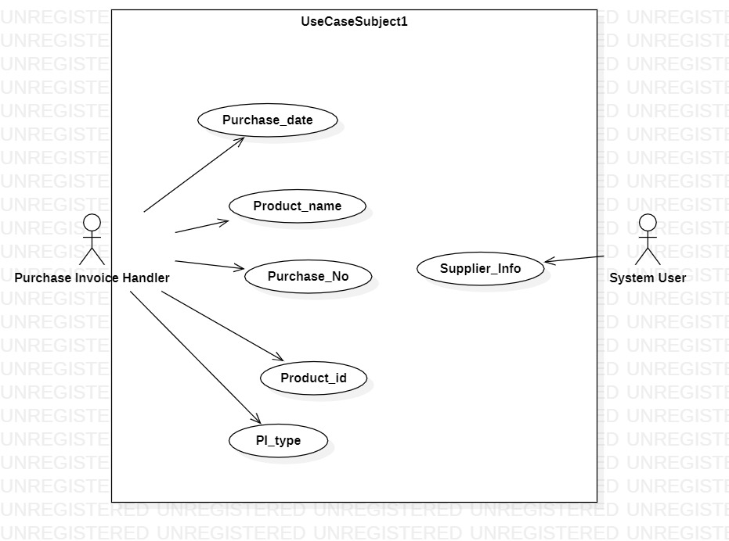

- Use case Realization:

- Flow of Event or Data Flow Diagram:

- Sequence Diagram:

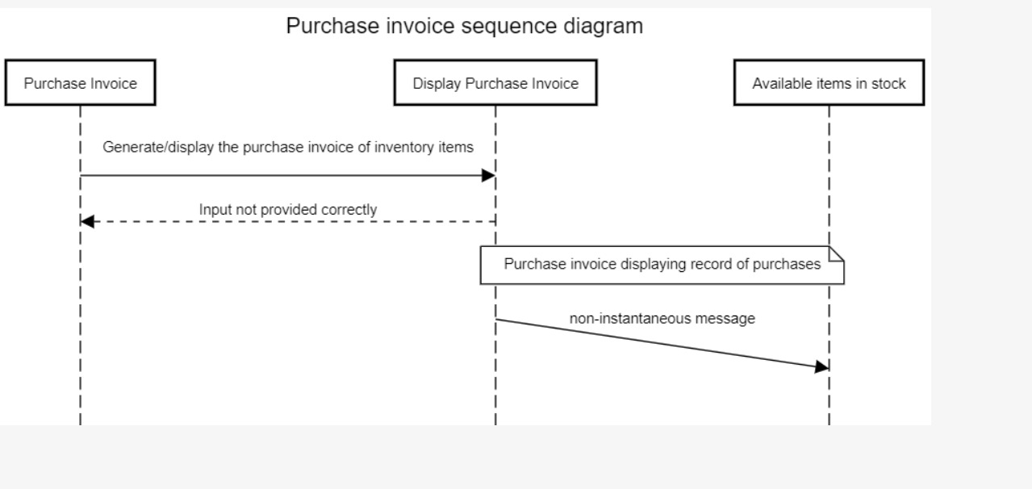

G) Collaboration Diagram:

H) Activity Diagram:

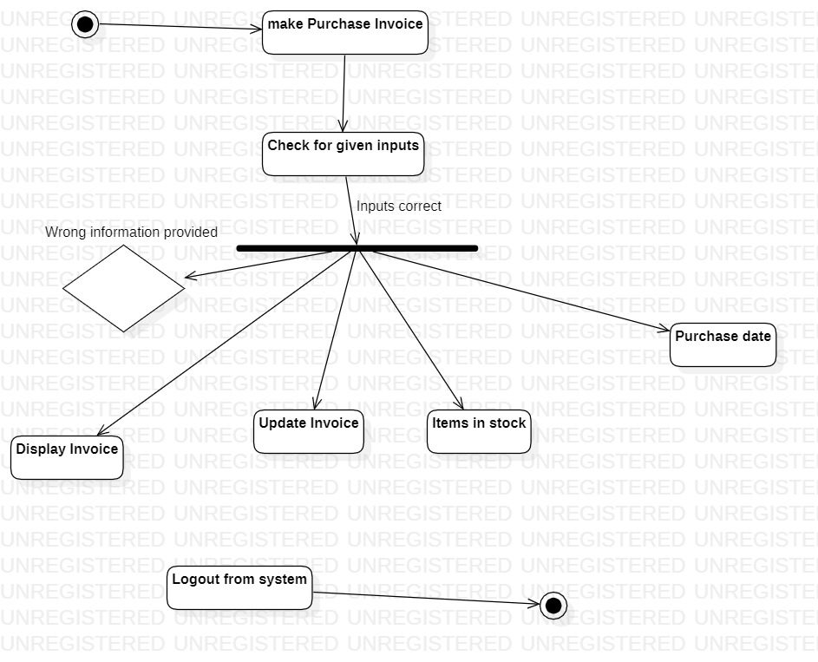

- Class Diagram:

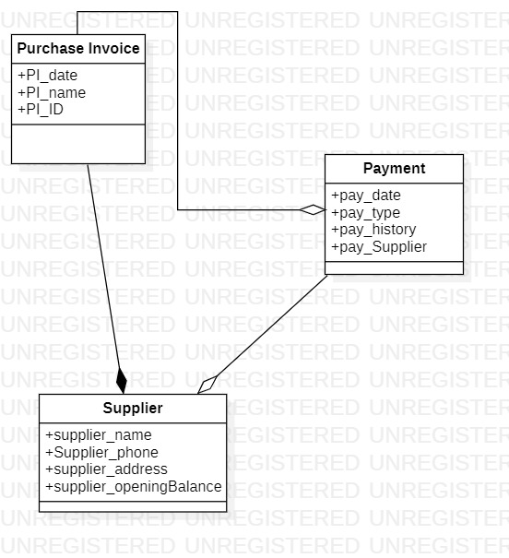

J) State Chart Diagram:

- 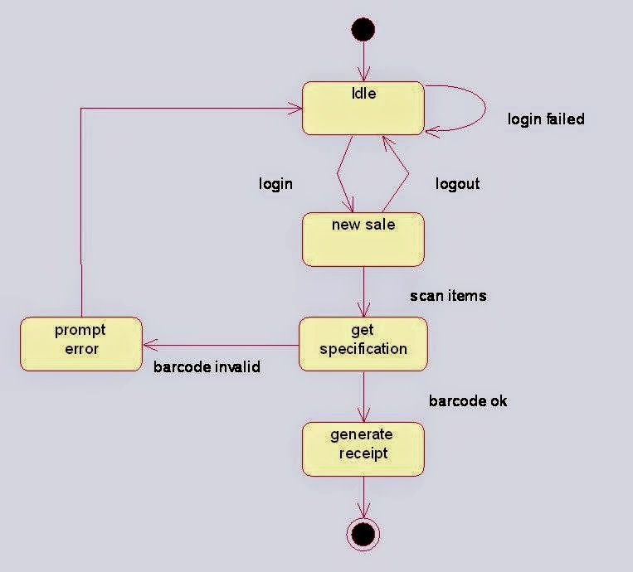

3.2. External Interface Requirements
3.2.1 User Interfaces :

User Interface the Graphical User Interface in the IMS consists of various options including Users, Stock, Supplier, Purchase Invoice, Sales, etc

☺☺ THANKS ☺☺

